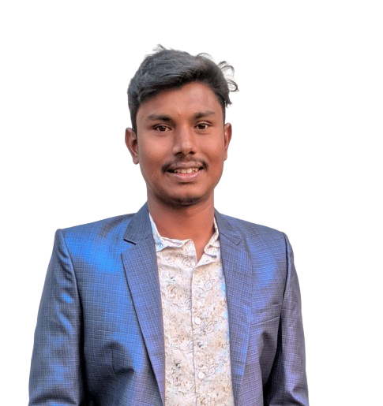
MD SAIFUL ISLAM

Phone:01759197389
E-mail:saifulislam30224@gmail.com
Location:Dhaolai,Hatibandha,Lalmonhat

LANGUAGE
Bangla
English

TRAINING
COMPUTER FUNDAMENTAL AND OFFICE APPLICATION.

Duration:3 month (60 hourse)
Institute: EDGE

HOBY
Social work
Travelling
Gardening

CAREER OBJECTIVE

To obtain a better position with opportunities to utilize
my practical SEO,branding & marketing and technical knowledge andexperiences,skill ,talent ,creativity,
Sincerely for the better achievement of the organization.
PROFESSIONAL EXPERIENCE

Content Developer:(January 10-2022 to be continuing.

Descriptions:

Creating content on Microsoft Excel.
Creating content on Microsoft Word.
Creating content on Microsoft powerpoint.

Department: Branding & Marketing

EDUCATION QUALIFIACTION:
Bachelor of science(B.Sc): 4th year running.

Higher Secondary School Certificate(H.S.C):
Board: Dinajpur.
Passing year:2019
Group:Science
Result:3.75 out of(5.00)
Secondary School Certificate(S.S.C):
Board: Dinajpur.
Passing Year: 2017
Group: Science
Result:3.95 out of (5.00)

SKILL ENHANCEMENT TRAINING:
Training Tittle: Data Entry Expert.
Duration: 3month.
Time :10 December 2024 to 10 February 2025.
Institute:BCCI

Areas of Strength:
⮚ Good interpersonal and communicational skills.
⮚ Ability adapt to new environment and willingness to learn.
⮚ Hardworking under pressure, loyal, honest and caring.
⮚ Self-motivated and ambitious with a strong desire to succeed.

Personal Information:

Father’s Name: Md.Babul Hossain
Mother’s Name: Mst.Monowara Begum
Date of Birth: 04-06-1999
National Id: 6264358687
Gender: Male
Merital Status: Unmarried
Religion: Islam
Nationality: Bangladeshi(By Birth)
Permanent Address: Village: Dhaolai,
Post office: Nowdabash ,
Pollice Station: Hatibandha,
District: Lalmonirhat.

Certification
I verify that all information started in this resume is true and complete to the best of my knowledge.

Md.Saiful Islam
Signature
Date:

